Class
A Class is a plan which describes the object. We call it as a blue print of how the object should be represented. Mainly a class would consist of a name, attributes & operations. Considering the above example, A Mobile can be a class which has some attributes like Profile Type, IMEI Number, Processor, and some more.) & operations like Dial, Receive & SendMessage.
e.g.
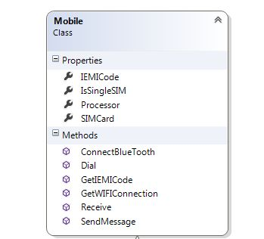

Objects
Any real world entity which can have some characteristics or which can perform some work is called as Object. This object is also called as an instance. If we consider the above example, a mobile manufacturing company, at a time manufactures lacs of pieces of each model which are the instances. This objects are differentiated from each other via some identity or its characteristics.

e.g.



